Subject: Business Economics
B.Com.-I
------------------------------------------------------------------------------------------

Q.1 What Are The Basic Problem Of Economy.
Ans. Synopsis
- Meaning Of Economy
- Types Of Economy
- Meaning Of Economic Problem
- Why Does An Economic Problem Arise
Central Problem Of An Economy

Micro Problem Macro Problem

- Conclusion
Ans. :- Meaning Of Economy :- It Is The System Of Earning Livelihood It Is Related To Production And Exchange And Vary Essential In Satisfaction Of Human Want In Order To Perform All These Activity We Realise Some System Organisation Or Structure This System Or Structure Is Known As Economy
“An Economy Is A System by Which People Get A Leaving and Satisfy Their Wants.” A.J. Brown
Types Of Economy:-
- Capitalist Economy Or Market Forced Economy
- Socialistic Economy Or Centrally Plan Economy
- Micro Economy
Meaning Of Economic Problem:- Due to scarcity of resources the society is faced with the problem choosing among the multiple wants for goods and services for the satisfaction to which scarce resources are used thus we have the problem of allocation scarce resources to achieve maximum possible satisfaction of want it is knows as economic problem
Definition—Economic problem is concerned with the use of scarce resources among alternative human wants and in using these resources to words the end of satisfying wants as fully as possible
Prof. Left Witch

Economic Problem Related To

Human Wants Resources Are
Are Unlimited Limited

Problem Of Choice

Problem Of Economising Scarce Resources

Economic Problem

Central Problem Of Economy

Micro Economic Problem Micro Economic Problem

- Allocation Of Resources
- What And How Much A)Fuller Utilisation
To Produce

B) How to Produce B) Problem Efficiency
C) For Whom To Produce C) Problem Of Economic Growth
(A) What and How Much To Produce
- Problem Of Choice Between Various Commodities
- Choice Between Consumption (Sugar Cloth) Car Capital Goods (Machine Tool)
- Choice Between Private (T.V. Mobile)
And Public Good (Roads ‘Schools)
- Choice Between Civil (Cloth ‘Shoes)
- As War Goods (Machine Guns Aircraft)
- Choice Between Mass (Bread ‘Butter )
And Luxury Goods
How Much To Produce
- Determines The Quantity Of Goods To Be Produced
- Allocation Of Available Limited Resources
( B) How To Produce:-
- To Determine The Manner By Which The Goods Are Produces
- It Is The Problem Of Choice Of Technology
- Choice Between Capital Based Techniques Car Labour Intensive Techniques
(C) For Whom To Produce
- Decision Regarding Distribution Of Income
- Distribution Of Income Between
- Different Group Of Society
- The Present And Future
- Distribution Of Income
In Capital Economy – On the Basis Of Purchasing Power Of Consumer
In Socialistic Economy- - On the Basis Of Consumer Needs
- The Present And Future
Consumer Goods Are Produced By Labour Based Techniques For Present
Capital Based Techniques for Future Requirements. Macro Economics Problem
- Fuller Utilisation Of Resources
- To Give Employment To All Resources (Land ‘ Labour)
- Fuller Utilisation Of These Resources
- Problem Of Efficiency
- Allocation Of Resources In Their Best Way(It Deals In There Aspects)
- Efficiency In Production
- Efficiency In Distribution
- Efficiency Of Allocation
- Problem Of Economic Growth
- To InCrease Production
- To InCrease Production Capacity
- To InCrease Employment Level
- Output By Advanced Technological Encasement
Conclusion--- The ultimate aim of the economy should be to make a choice in such a manner that the optimum production may be obtained from the scarce resource these economy solve their basic problem by price mechanism .
Q.2) What Do You Mean By Elasticity Of Demand Explain It Degree ?

Synopsis

- . Meaning Of Demand
- . Definition Of Demand
- . Law Of Demand Meanings And Determinants
- . Meaning Of Elasticity Of Demand
- . Kinds Of Elasticity Of Demand
- . Conclusion

Ans.--- Demand may be defined as the amount of the commodity purchased or desired by a person at a given paint place time a at a given price.

Demand = Effective Desire + Willingness + Ability(Availability of means)

Definition :
“ Demand For A Good Is A Schedule Of The Amount That Buyer Would Be Willing To Purchase At All Possible Price At One Instance Of Timing”.
By: Mayor

Increase
Decrease

Law Of Demand -- The Relation Between Price To Sales In Know As Law Of Demand According To This Concept The Law Of The Demand States That Higher The Price Lower The Demand And Lower The Price Lower The Demand And Lower The Price Higher The Demand In Other Weld Law Of Demand Shows The Inverse Relation Between Price And Quantity Demand
P --- QD
P--- QD

Determinants / Factors Influencing
- Price Of Commodity

P D
P D
- Income Of Consumer
A)Special Goods

I ----- Qd
I ----- Qd -------Direct Relation
- Inferior Goods / Giffin Goods

I ------- Qd
I ------- Qd ---------- Inverse Relation
- Taste And Fashion ----
Change In Taste And Preference Qd

Change In Taste Preference Qd
- Expectation Of Consumer About The Future Anticipation About Future Price

Fp Qd
Fp Qd
- Advertisement And Publicity Effect

Advertisement Q D
Advertisement Q D
- Price Of Related Goods

Related Goods
--------------------------------------------
Substitute Goods Complementary / and Goods

---------------- --------------------------
X Or X X And X
X Price Y Qd X Price Y Demand

X Price Y Qd X Price Y Demand

Meaning Of Elasticity Of Demands -----
The Concept of Elasticity Of Demand Is Evolved By Pray J. S. Nil The Concept Of Elasticity Refers To Degree Of Responsiveness Of Quantity Demand Of A Commodity To A Change In any Of Factor Affecting Its Demand .

Ed = % In Demand Of A Commodity
---------------------------------------
% Change Of Determinant Of Demand
Elasticity Of Demand Are Of Three Types
- Price Elasticity Of Demand ;----- It Represent to a % Change
In Demand Of A Commodity With % Change In Price.
- Income Elasticity Of Demand
It refers to A % Change in Quantity Demanded With a % Change In Price
- Cross Elasticity Of Demand
It Refers to a Proportionate Change In Demand Of a Commodity With Respect To Proportionate Change In Price Of substitute and complementary Goods .

Price Elasticity Of Demand
Price Elasticity Of Demand Is The Percentage Change In Quantity Divided By The % Change In Price

Kinds Of Elasticity Of Demand
- Perfectly Elastic Demand ----- Demand For A Commodity Is Said To Be Perfectly Elastic When The Demand For It May Increase Or Decrease In Slight Change In Price Lead To Infinite Change In Quantity Demand

Price -----------------
-------------------
Quantity Demand
Ox Axis ----- Quantity Demand
Oy Axis ----- Price
Paralled To Ox Axis Which Indicates Singly Price Increases Qd Becomes Zero Ed Can Be Denied As
Ed = X
Example -------- Imaginary Situation
- Perfectly Indistinct Demand ------ Demand For A Commodity Is To Be Said Perfectly

------------ No Change
Inelastic If Quantity Demand Does Not Change In Response To Change In Price

Price P Qd -----
P Qd -----
Ox ------ Level Of Quantity Demand
Oy ------ Price
Do ------- Demand Course Parallel To Axis Which Indicates No Change In Demand With Change In Price
Ed = 0
Eg ;----- Salt
- Unitary Elastic Demand ;---- Demand For A Commodity It Said To Unit If % Change In Qd As Equal
To % Change In Price For Eg If Price 25% Qd 25% Price 25% Qd 25%
Ox --- Quantity Demand
Oy --- Price Level
Do Clove – Hyperbola Shape Which Indicates % In Price Is Equal To % S In Qd
Eg ----Cloth
- More Than Unitary Elastic Demand For A Commodity Will Be Said To More Than Unitary If % Change in Price Is < Than % Change In Quantity Demand

Pl
P
Pl
O-Q2------Q---------Q1
For Eg If Price 25% Qd 30%
Price 25% Qd 30%
Ox---- Quantity Demand
Oy---- Price Level
Qd---- Extension In Curse
Which Indicates
% In Qd Is > % Charge Price
Eg ;-- Car
- Less Than Unitary --- Demand For A Commodity Is Said To Be Less Than Unitary If % In Price Is Great Than % In Qd

For Eg --- Price 10% Qd 7%
Price 10% 7%
Ox --- Quantity Demand
Ox --- Price Laud
Demand Clue ----- Inelastic Which Indicates % In Price > % $In Qd
E G ;--- Tea
Method To Measure Elasticity Of Demand
----------------------------------------------------------------------------------------------------------------
Total Expenditure Method Propounded Method Point Method Are Method
- Total Expenditure Method ;---- This Method Is Propounded By Marshal According To This Approaches Total Expenditure Is Considered For Determination Of Elasticity
P Qd T E ( P X Q D )
10 1 10
09 2 18 More Than Unitary
08 3 24
07 4 28
06 5 30 Unitary Elastic Demand
05 6 30
04 7 30
03 8 28
02 9 18 Less Than Unitary
01 10 10

P Q D T E
P Q D T E More Than Unitary

P Q D T E
P Q D T E Unitary Elastic Demand
P Q D T E Less Than Unitary
2) Proportionate Method ;--- This Method Is Associated Coined By Dr. Marshal Price Elasticity Of Demand Is The Ratio Of Percentage Change In The Amount Demanded To Percentage Change In Price Of Commodity

E D= ( - ) Q P Q P Q – N Q -- B G
-----------* ----------- = ------------* ----------
Q P P Q P –- N P –-- B P
Ng New Quantity Ans = 1—Unitary
B G Base Quantity < 1 -- Less Than Unitary
< 1 – More Than Unitary
N P New Price O --- Perfectly Inelastic
B P Base Price < --- Perfectly Elastic
Another Name – Flux Method Ratio Method Arithmetic Method
3 Point Method ------ This Method Is Coined By Alfred Marshal Point Elasticity Measured By The Ratio Of Lower Segment Of The Curse Below The Given Point To The Upper Segment
E D = L S
---------------
U S
L S = Lower Segment
U S = Upper Segment
E < Upper Segment = 0
E > L S > Us
E- 1 Ls Us
E< 1 Ls < Us
E=O Ls = 0
- Arc Elasticity Of Demand ;-- Arc Method Of Elasticity Is Calculated By Average Price And Average Quantity Demand

- Arc Elasticity Of Demand

- ------------ Ap P 1 + Pl
- -------- ---------------
- Ap Q1 + Ql
- Ag- Nq Bg ( New Quantity Base Quantity )
- Ap- Np Bp ( New Price Parse Price )

- An 1. Unitary >1 ----- More Than Unitary
- < 1less Than Unitary

- Income Elasticity Of Demand
- Income Elasticity Of Demand Means The Ratio Of The Percentage Change In Quantity Demanded To The Percentage Change In Income It Is denoted By eg:

- E Y = Y A Q
- ---------*------------
- Q Ay
- Y: Income Quantity Demanded
- A—New Quantity Initial Quantity
- Y--- New Income Initia L Income
- Type Of Income Elasticity

- Zero Income Elasticity

- Y Qd ---- Income Qd ----
- Y Qd---- Income Qd----
- E G Essential Commodities Like Salt
- Negative Income Elasticity

- Income Qd
- Income Qd
- E G ;- Infernal Good
- Positive Income Elasticity

- Income Qd
- Income Qd
- E G ;-- Comfort $ Luxury Good
- Positive Income Elasticity Has 3 Condition
- % In Quantity Demand = In Income ---------- Unitary
- % In Quantity Demand > % In Income ------ More Than Unitary
- % In Quantity Demand < % In Income ------ Less Than Unitary

- Cross Elasticity Of Demand
- It Is the Ratio Proportionate Change In The Quantity Demand Of Y To R Given Proportionate Change In Price Of Related Goods

- E X = P Y Q X
- Qx X Py
- E X = cross Elasticity
- P Y – Original Price Of Goods
- P Y – ( New Price Of Y Good –Initial Of Y Good )
- Q X (New Quantity X Goods – Initial Quantity Of Goods )
- Types Of Gross Elasticity
- Positive ---( In Case Of Salestitute Goods )
- P Q X Q Of Y
- P Of X Q D Of Y
- Negative ( In Case Of Complementary Goods )

- P Of X Qd Of Y
- P Of X Q D Of Y

Q.3) What is ISo Product Curse Give Its Properties?
Ans. Iso quant = iso + quant
equal + quantity
Iso curve is locus of points representing the various combinations of two input yielding the same level of output iso quant is a curve on which the various combinations of labour and capital show the same output.
- Two Factors
- Various Combinations
One Factor One Factor
Level Of Output ------ Same

X Y Output
A 1 15 100
B 2 12 100
C 3 10 100
D 4 9 100
Properties Of I So Quant
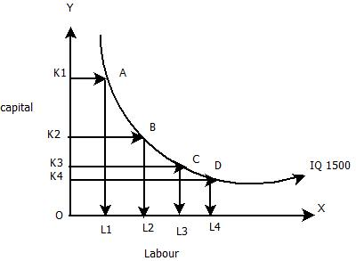
Properties of iso Quant
- Negative Slope ---- One Factor Another Factor
- Convex To Origin ---- Marginal Rate Of Substitution
- No Two I So Quant Can Interned Each Other
- An I So Quant Lying Above And To The Right Of Another Represent A Higher Output Level
- I So Quant Need Not Be Parallel
- No I So Quant Can Touch Either Axis ---- Factor Output Can Not Be Zero

Q.4) Discuss the Law Of Diminishing Returns How Is It Applicable To Every Type Of Economic Activity
Ans. Law Of Diminishing Return - According to this law as the proportion of factor is changed the total production at first increase more than proportionately this law studies the relationship between one variable factor of production and keeping the quantity of other factors fixed
Another name ------- short run production factor
Relation between ------- variable factor and output
Relation between :
- Total production
- Marginal Production
- Average Production
Stages Of Production
- Increasing Return Stage
- Decreasing Return Stage
- Negative Return Stage
(For Various Stages Refer Graph)
- Increasing Stage –
T P (Increasing rate ) M P A P
M P > Ap

Decreasing Stage
T P N P A P
------------------------------------------
( Become Negative )

Relation Between T P And N P
- When N P Is Positive T P Increase At Increasing Rate
- When N P Is Zero T P Reaches To Its Maximum Point
- When N P Is Negative T P Starts Declining

Here T P Total Product
AP Average Product
N P ------ Marginal Product
Return To Sale / Long Run Production Function :-
Long run is defined as that period of time in which all factor of production are variable in long run all the input are become variable the scale of production can be change by installing new plant and equipment by hiring more labour and other factor input long run production function is also known as return to scale
In return to scale the percent change in factor input is compared with the percent change in factor out put computation of % change in factor input.
( New Unit Of Factor Input – Initial Unit
-----------------------------------------------------X 100
Initial Unit

% Change In Factor Output
new unit of factor output --- initial unit of factor output
------------------------------------------------
initial factor output

- Types Of Return To Scale

- Increasing Return To Scale -----
% Change In Factor Output >
% Change In Factor Input
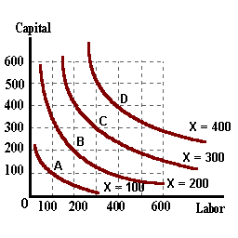
Factor Input 100% F Output 200%
- Constant Return to scale
% Change In Factor Output = % Change In Factor Input
Factor Input 100% = Factor Output 100%

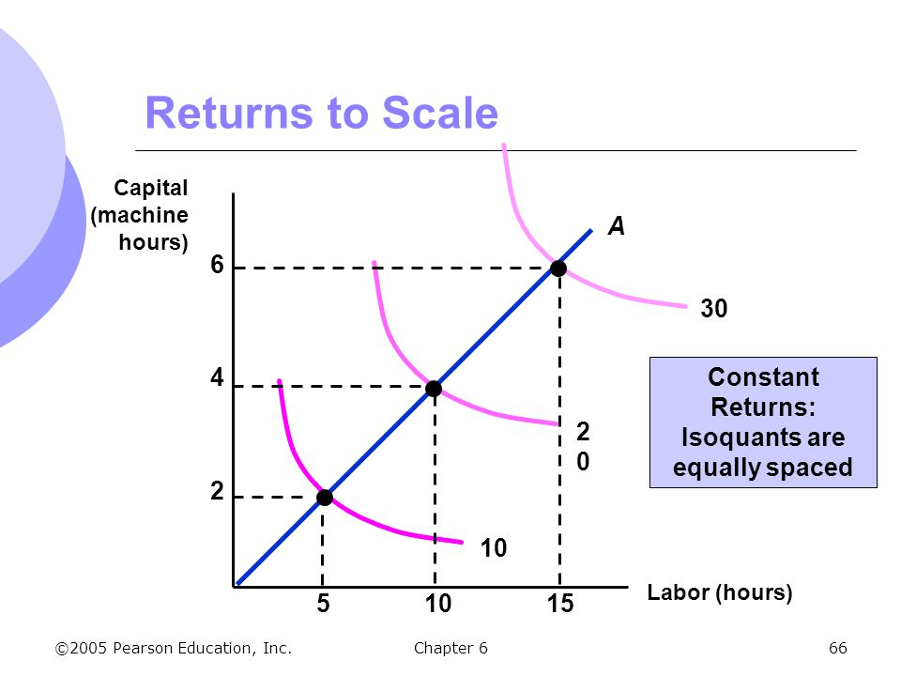

Decreasing Return To Scale:

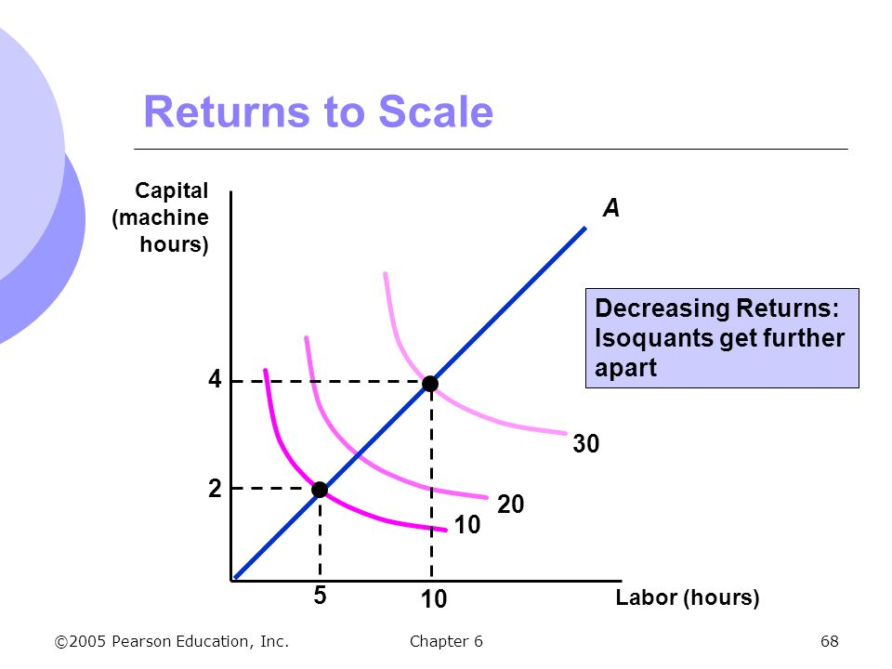
% Change In Factor Output < %Change Factor Input
Factor Input 100% > Factor Output 80%
( Make Graph )

Q.5) How Price Is Determined Under Perfect Competition Market
Ans. Perfect competition refers to a market situation in which are large number of buyers and sellers of homogenous product the price of the product is determined by industry with the force of demand and supply.
Definition –
Perfectly competitive market is a situation where large number of buyers and sellers are engaged in the purchase and sale of identically similar commodities who are in close contact with one another and who buy and sells freely among them selves

Boding
Characteristics ;--
- ------ Large Numbers Of Buyer And Seller
- ------ Homogeneous Product
- ------ Freedom Of Entry Car Exit
- ------ Perfect Knowledge Output Market
- ------ Perfect Mobility
- ------- No Transport Cast / No Selling Cast
- ------- Absence Of Artificial Restriction
- ------- Homogeneous Price Level
- ------- Horizontal Average Revenue Curve
Price Determination Under Perfect Competition Market
Under perfect competition price of a commodity is not determined by any individual seller car firm it is determined by the force of demand and market supply of commodity .
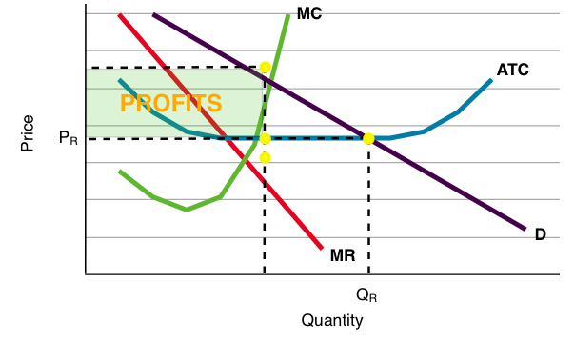

In perfect competition market industries are price maker and
firms are price taker.
Price Determination
---------------------------------------------
Short Run Long Run

( Supply Could Not Be Adjusted As Per Demand) ( Supply Can Be Adjusted As Per Demand )
--------------------------------------
Total Revenue / Marginal Revenue Mr And Nc Approach
Total Cost / And Marginal
Approach / Cost Approach

---- Maximum Level --------- Equilibrium ( Max. Level
---- Maximum Perfect --------- Firms Position
--------- Decision Making
In Case Of Loss
Total Cost And Total Revenue Approach
Under This Approach A Firm Is In Equilibrium When It Produces The Amount Of Output At Which The Different Between Total Revenue And Total Cost I.E. Total Project In Maximum

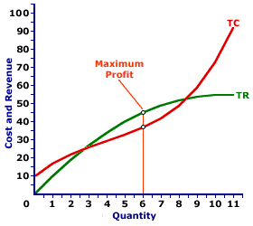

      - Trend Of Revenue Curve ----- The Revenue Curve Is Straight Line Which Means Revenue In Cercal At Constant Rate Due To Equal Price Level.
Trend Of Cost Curve------ It Lies Above The Cardigan Become Of Total Fixed Cost.
      - Equilibrium Output --- The Level Of Equilibrium Output Where The Difference Between Total Cost And Total Revenue Is Maximum .

Marginal Revenue And Marginal Cost
According to this approach the level of output where marginal revenue (m r) and marginal cost (m c) and marginal cost (m c) equal is the point of project
CONDITION FOR EQUILIBRIUM
- The Firm Rill Be In Equilibrium When Two Conditions Are Satisfied

A --- M C= Mr
B --- M C Curve Intersect N R from right upward
Firms Position ;---- In short run at equilibrium level of output a firm can be in following three situation to know firms position average revenue ( AR) and average cost ( AC) is compared

- Normal Profit ---- It Is A Situation Where Ac = A R
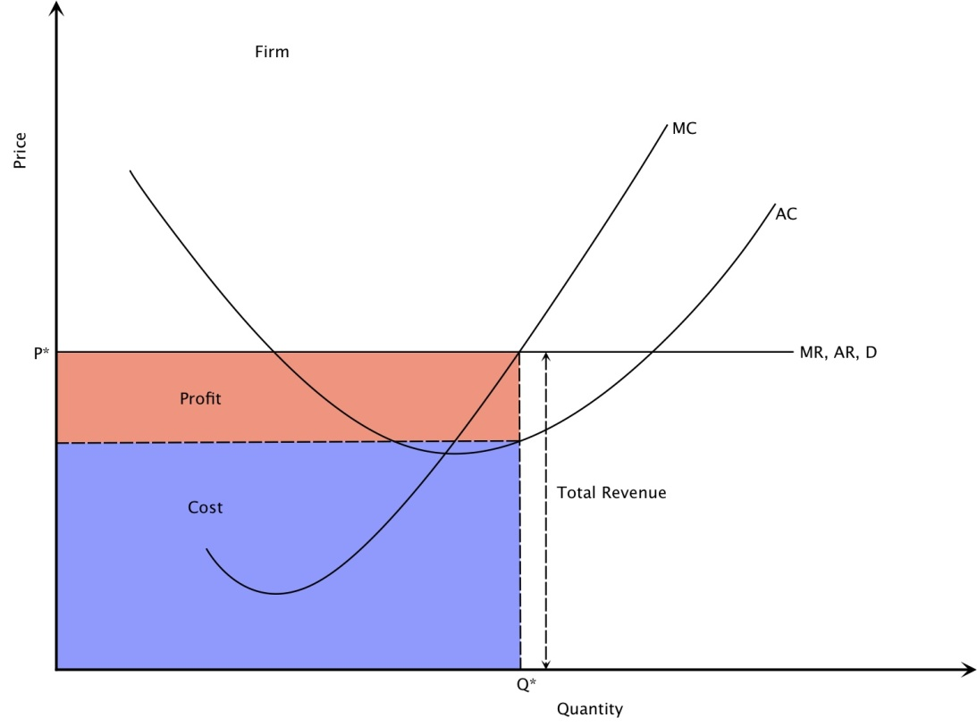

- Super Normal Profit ---- It Is A Situation Where A R > A C
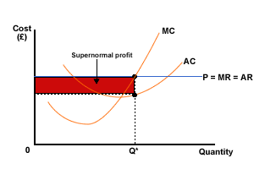
- Loss ---- It Is A Situation Where A R < A C
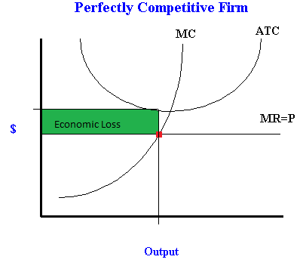
Decision Making ---- The variable cost alone in short period determine firms decision for decision regarding continuance as shut down beeriness a r is compared with avc
- ip ar > avc
----- variable cost is covered and paid of fixed cost is also covered so business should continue
- Ip Ar = Avc
Average Various Cost Is Covered Business Should Continue
- Ip Ar < Avc
arc is not covered so business should be shut down

PRICE DETERMINATION IN LONG RUN THOUGH MR AND MC
In Long Run Firms Equilibrium In The Point Where Its Long Run Maligned Cost ( Lnc ) Is Equal To Long Run Maligned Revenue ( Lmr ) In Long Run The Firm Under Perfect Competition Market Krill Be In Normal Project Stage I.E.

LMC = LMR ( EQUILIBRIUM )
LAC = LAR ( Normal Profit )

Q.6 ) Define The Term Monopoly How Price Is Determined Under Monopoly Market ?
Monopoly
Mono + Poly
( Single ) + ( Seller )
Monopoly is a market stricture is which a single firm is setting a product for which there are no close substitute .
Definition --- A monopoly is a seller who is confronted with a falling demand curve for their product

Leona
Feature Of Monopoly
- Single Seller
- No Close Substitute
- No Entry Of New Firm
- Selling Cost Are Very Small
- The Demand Curve Is Tend To Be Less Than Unitary Elastic Demand

Price Determination Of Monopoly Market
------------------------------------------------------------

T R and T C Approach M R and M C Approach
- Total Revenue And Total Cost Approach
According to this approach a firm is in equilibrium when it product that amount of which the difference between T R And T C Is Maximum
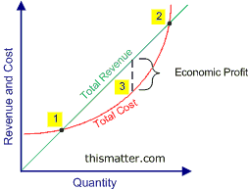

2.Marginal Revenue And Marginal Cost Analysis

------------------------------------------------------------------------------

Short Run Long Run – Equilibrium
Equilibrium ( L M C = L M R )
( Super Normal )
(Maximum Level Of Output) (Profit)

Condition Of Equilibrium Selling Cost %
- M C = MR No Close Substitute

- MC cuts MR from its below points

Supply Can Be Adjusted as Per Demand
Firm Position :
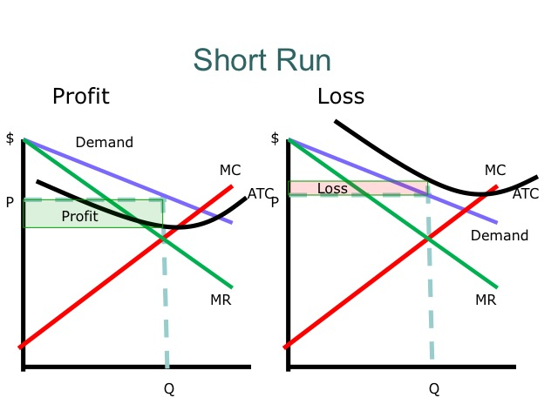

( Super Normal Project ( A R > A C)
- ( Loss ( A R < C )
- Decision Making ( In Case Of Loss )
- A R > A V C =A V C Pat Of A F C
- Covered ( Business)
- A R =A V C = Business Should Continue
- A R < A V C =Shut Down

Q.7) What Do You Mean By The Term Discriminating Monopoly ?
Ans . Price discrimination refers to the produce of selling the same commodity at different price to buyer monopolist usually change different price for the same product at the same time from different customer .
Degrees of price discrimination
- Price discrimination of first degree
- Price discrimination of second degree
- Price discrimination of third degree
Price determination of first degree ;- It Is
also known as perfect price discrimination price discrimination of first change occurs when monopolist is able to self each separate unit of commodity at different price.
Price discrimination of second degree:
In this type seller decides his market in to different group of buys from each group of buyer a different price is changed by seller.
Price Discrimination Of Third Degree --- Within this the seller classifies his market in to different sale market each sale market the seller fixed different price based an the elasticity of demand in sub market .

Types Of Price Discrimination

Personal Discrimination Local Discrimination Trade Discrimination
--- Different Price --- Different Unit Same Commodity
--- Same Commodity --- Different Price Same buyer – Low Price
--Different Customer Different State Same buyer – High Price

Condition Of Price Discrimination
- ----- Difference In Elasticity Of Demand
- ----- Discriminatory Firm Should Be Monopolistic
- ----- Restriction On Entry
- ----- Transport Cost
- ----- Legal Sanction
- ----- Lack Of Communication Among Buyers

Q8) How equilibrium and price determined under imperfect or monopolistic market ?
Ans . Imperfect competition is that market situation which lies in the intermediate position of monopoly and perfect competition this market situation is wined By Mr. John Robinsons.
Definition --- Monopolistic competition is a market situation when the are many produce but each offer a slightly differentiated.
Lim Clung Yam
Features Of Monopolistic Competition
- ------ Existence Of Large Number Of Firms
- ------ Product Differentiation
- ------ Freedom Of Entry A Exit Of Firm
- ------ In Perfect Knowledge
- ------ Non Price Competition
- ------ Non Elastic Demand
- ------ Less Mobility
- ------ Selling Cuts

Kinds Of Imperfect Competition
--------------------------------------------------------------------------------------------
Duopoly Oligopoly Monopolistic
Duo +Poly Oligo+Poly Scale Group Of Imperfect
( Two Seller ) ( Few Seller) Competition

Determination Of Equilibrium / Price Under Monopolistic

Tr And Tc Mr And Mc
Approach Approach
Same As Monopoly

Short Run Equilibrium Long Run Equilibrium
Profit : Firms Position No Profit No Loss
Loss : Lac = Lar
Ac < Ar
Decision Making
Ar > Avc
Ar =Avc Business Continue
Ar = Avc Shut Down

Q.9) Critically explain the various theory of rent ?
Ans. It is know to us that production is the combined effort of factor of production .
P= F (N+ C+L)
P= Product
F=Function Of
N= Land C = Capital L= Labour
The reward which the owner of land gets for allowing its use is generally termed as rent
Rent – Reward Paid To Landlord As Remuneration Of Land In Production Process

Types Of Rent

---------------------------------------------------------------------
Contract Rent Scarcity Rent Differential Rent
Contract Rent –amount paid to owner of land as per the agreement it is also known as gross rent.
(2) Scarcity Rent –Rent Is The Prices For Use Of Scarce
Resource (Land )
Land Supply ---- (As Natural Gift )
Demand
(Production )
Differential
Differential Rent --- Land Differs In From Fertility And Situation From Maker
High Fertile Land Production Rent
Less Fertile Land Production Rent
Theory Of Rent
-------------------------------------------------------------------------------------------------------------------------Recardian Theory Modern Theory
( Traditional Theory ) ( Propounded By )
( Propounded By David Ricardo) Mr. John Robinson
Rent Under Extensis Cultivation Rent Arises Due To Scanty Of Land
Supply Of Demand > Demand Of Land Rent Is Earned By All Factors
Less Population Rent Is Difference Of Actual Easing And Triangle Easing
High Fear Tile Land = In To Marginal Land 1) Scarify Rents
Less Fear Tile Land = Marginal Land When Of Land < Supply Of Land
Rent From Marginal Land
Marginal Land

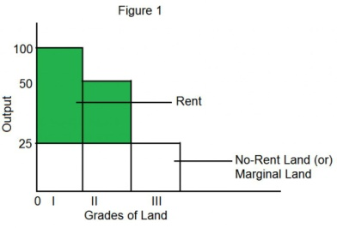

( Make Graph )
--- Rent Under Intensive Cultivation Supply 2) When > S
Of Land < Demand By Land (Population ) -- Rent Crises
Rent ;- Actual Caning – Transfer Ealing
Rent --- Surplus From Intra Marginal Land— A) When Supply Is Perfectly Elastic Econom
Surplus From Marginal Land Rent – Zero ( Make Graph )
---- Situational Rent (B) When Supply Is Perfectly Inelast.
Transfer Equine – Nil Economic Rent – Again ( Make Graph)
( Rent Arises Due To Situation Of Land From Maker (C) When Supply Is Relative Classic
The Interesting Point Of
Demand $Supply Clues

Q.10) Explain Various Theories Of Profit ?
Ans. The Profit is the remuneration to the enterepleneus for his services rendered on the production process .

Profit
-------------------------------------------------------------------------------------------------------------------------Residual Income Reward For Entrepereneurial Service
( Arises After The Payment To All Factor Of Innovation Risk And Uncertainty Bear.
Production Say Land Labour Capital

Types Of Profit

-----------------------------------------------------------------------------------------------------------------------
Gross Profit Net Profit Normal Profit Abnormal Profit

- Gross Profit
Total Revenue -- Explicit ( Amount Paid To External Factor Like Labour
Incan Capital)

Constituents Of Gross Profit
Gross Profit = Reward Of The Factor Of Production Supplied By Enter Lance
(+) Maintenance Charge
(+) Personal Profit Factors White Determining Of Price
(+) Profit From Innovation
(+) Profit From Product Differentiation

- Net Profit
Total Revenue – Total Cost
( Unit Sold X Price ) – ( Explicicast + Implicit Cost )

.

